Portraiture & 3D - Ordinary Extraordinary Predicted grade:
Assessment objectives. This is the criteria that your coursework and exam will be marked using.
A01- Develop ideas through investigations, demonstrating critical understanding of sources. Looking at artists and cultures, comment on what you understand!
A02- Refine your work by exploring ideas, selecting and experimenting with appropriate media, materials, techniques and processes.
A03- Record ideas, observations and insights relevant to intentions as work progresses. Note all ideas and how you arrived at them. Make connections!
A04- Present a personal and meaningful response that realises intentions and demonstrates understanding of visual language. A final artwork to the best of your ability, which communicates your idea!
Key words
Analysis- Use help sheets to comment and evaluate the work
Technique- How an artist uses materials
Personal response- Using what you have learned from the artist, use their technique to create your own version.
Annotate- Comment on what has gone well, what could be improved, what you have used any why
Artist study- collage of artist work, facts and own thoughts.

Welcome to Yr10 GCSE art! This term we will be exploring a range of artists and skills. This will help you to develop artistic techniques and give you a strong range of artists and new ways to communicate ideas as well as the confidence to support your coursework and exam units.

How to use your Sketch Book
Your sketch book is the place for you to record your personal studies to support this project. Information such as your artist studies, gallery visits, found images and ideas should go in here. This gives you the opportunity to deepen your response to this project and make it more personal. Your teacher will give you some ideas and you may add your own. Do fill pages and keep it looking exciting and relevant. Annotations always help explain ideas.
Use help sheets provided when need! Use art clubs when need!
Your presentation should reflect the work involved.

Term | Activities | Example | Notes | Term | Activities | Example | Notes
Term 3  Week  21-26 | AO covered AO2 & AO3 Missing Incomplete Complete  - To research, study and analyse artworks based on the  theme of Portraiture. MIND MAP AND MOOD BOARD TO START  - To explore the use of FORMAL ELEMENTS, including line,  tone, colour, form, composition and light through visual studies.  - Explore a range of medium/materials used to create  Portraits: draw, design, collage, and experiment, review and refine  your techniques. Working in both your sketchbook and large scale. | 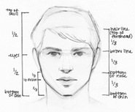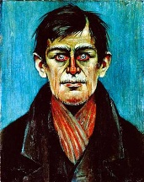 |  | Term 1  YR10  Week  1-5 | AO covered AO2 & AO3  - We will look at and discuss the portrait works of Xenia Hausner/Jenny Saville– why are we looking at this artist? We will create artworks in response to this artist’s works, exploring Paint techniques and medium. Using PRIMARY sources!  Have studies of this artist in sketchbooks, showing examples  of their work and start to note facts and our own responses  both written and visual. Exciting – creative presentation! | 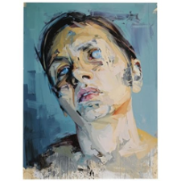
Term  3  Week  27-28 | AO covered AO1  - We will look at and discuss the portrait works of Maggi Hambling – why are we looking at this artist? How do they link to our project so far?  - We will create artworks in response to this artist’ works, exploring drawing techniques and medium. Composition and introduction of colour and form. SCALE!  - Have studies of this artist in sketchbooks, showing examples of their work and start to note facts and our own responses both written and visual. Exciting – creative presentation! | 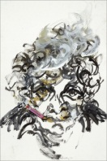  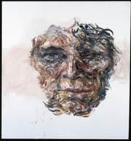 |  | Term 1  YR10  Week  6-7 | AO covered AO1 & AO2  - We will look at and discuss the portrait works of Andy Warhol/Pop art – why are we looking at this? We will create artworks in response to this artist’s works, exploring PHOTOSHOP. Using PRIMARY sources!  - Have studies of this artist in sketchbooks, showing  examples of their work and start to note facts and our own  responses both written and visual.  Exciting – creative presentation! | 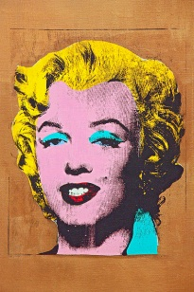
Term 3  Week  29-31 | AO covered AO1 & AO2  - We will look at and discuss the portrait works of Stanley Spencer/Chiaroscuro – why are we looking at this artist? We will create artworks in response to this artist’s works, exploring drawing techniques and medium. Composition and introduction of tone and form.  - Have studies of this artist in sketchbooks, showing examples of their work and start to note facts and our own responses both written and visual. Exciting – creative presentation! | 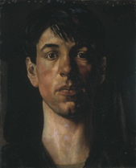 |  | Term 1  YR10  Week  8-12 | AO covered AO1 & AO2  - We will look at and discuss sculptural works of Giacometti and/or Eduardo Paolozzi and /or Jason Decaires Taylor– why are we looking at these artists? We will create 3D pieces in response to this artist’s works, exploring form, techniques and medium (clay).  Have studies of this artist in sketchbooks, showing examples of  their work and start to note facts and our own responses both  written and visual. Exciting – creative presentation! | 