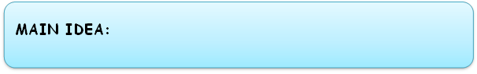

**You can note or sketch the composition/layout of your photo/idea in these boxes. Think different viewpoints etc?**

**Version 3**

**Version 2**

**Version 1**

**You can note or sketch the composition/layout of your photo/idea in these boxes. Think different viewpoints etc?**

**Version 3**

**Version 2**

**Version 1**

**MAIN IDEA:**