Stimulus
- Link the Drama key words with the correct definition:

Stimulus
Symbolism
Devised

A starting point, something that gives you an idea for a performance.
The use of images or props which represent something else. They are not literal.
An original performance created through rehearsal
3 Mark

- List 5 examples of a stimulus:
5 Mark

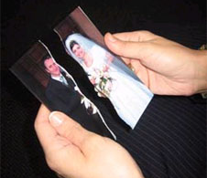
- Look at the image below. Imagine this is your stimulus. Annotate the stimulus with original ideas for a performance

4 Mark

- Think back to a performance where you used a stimulus.
2 Mark
Explain how you used your stimulus to create your original idea:

2 Mark
- Evaluate the advantages of using a stimulus to devise a performance:

- Evaluate the negatives of using a stimulus to devise a performance:
2 Mark

